**What should a VLE provide?**

The current use of the term VLE is incorrect. Learners do not control it, teachers do – as in a classroom. It should be a VTE.

The left circle represents the teacher, whilst the one on the right is the VLE.

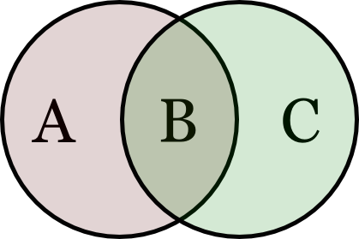

1. It should not be a teacher. Teachers are good at providing adaptive learning, much better than machines.
2. It should be a back-up to a teacher. It can be used as a repository or to provide tests, etc. as VTEs do now.
3. It should provide services a teacher cannot (John Hattie), for example, multiple learning styles simultaneously or out of hours teaching.